





**Beginning Your Career in Teaching – *Making the transition into your NQT year***

Student Teacher: Mark Gadsby   
  
Subject Tutor: Miles Berry  
  
Subject Specialism: Computing

**How to use this document for the student teacher/NQT and the employing school/mentor:**

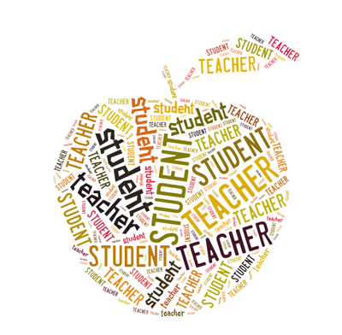

**The student teacher/NQT**

This document is an essential part of the transition between your training and the induction year. It performs several tasks. First, it serves as a summary of your training, giving you an opportunity to briefly map out some key aspects of this. Secondly, it includes the NQT year targets that you will have set with your university tutor. These must be passed onto the NQT coordinator and mentor at your first teaching job in order to support the mapping out of your NQT training plan. It also enables you to reflect on where you are currently and where you might see yourself to be by the end of the NQT year.

**The employing school/NQT mentor**

We hope that you will find this document a useful insight into targets that were set for the NQT year at the end of PGCE Secondary programme. It aims to bridge the gap between the PGCE and first appointment. It should provide a basis for supporting development and your new employee’s CPD needs. The targets emerge from meetings at the end of the student teacher’s placements and in discussion with tutors at the university.

Students on the PGCE programme this year completed two contrasting placements, one of these was truncated by the effects of the coronavirus. This has implications for all our NQTs.  
  
*Thank you for all the support you will give our NQTs over the next year and we are here to talk to if you want to get in touch.*   
*Contact details are on the back page.*

**PART 1: Self-Reflection: Achievements, strengths and career development**

|  |
| --- |
| **What do you consider your main strengths and achievements during the course as a student teacher and a learner to date?** |
| **As a student teacher:**  **More confident about facing a class and dealing with low level disruption.**  **Learnt how to channel my subject knowledge and experience into effective teaching resources.**  **As a learner:**  **Much more confident about expressing myself on paper. Much quicker and more concise. Very pleased with the marks achieved for my assessments.**  **I have spent a lot a productive time broadening my subject knowledge this year. I am now completely unphased by anything in the GCSE speciation and 80% of the ‘A’ level.** |
| **What aspects of teaching do you find the most interesting and rewarding?**   * ***What has led to your interest in these areas?*** * ***How would you like to develop these interests in your NQT year?*** |
| **I think physical computing has great potential as a teaching tool and a way of triggering inspiration in students.**  **The raspberry pi/micro-bit/arduino making movement has always been interesting to me because it allows for the simulation of real-world applications in a manageable and safe way. Very empowering in my view.**  **I will run after school clubs to develop these interests and where possible incorporate into my lesson planning.** |

**Self-reflection: Range of placements**

We work hard to ensure you experience a range of placements throughout your time on your course. These vary depending upon the area you are placed in, school results data, Ofsted grading, pupil premium and/or free school meals and key stages. We hope you feel you have experienced a range of different experiences! Reflect on them below but do not name the schools.

*Indicate your course:*

|  |  |
| --- | --- |
| Subject  Computing | 11-16 (and post 16 for English, History and some students in other subjects) |

|  |  |  |
| --- | --- | --- |
|  | **Placement 1** | **Placement 2** |
| **Type of school: free, academy, community, faith, independent** | Academy | Sixth Form College |
| **Year groups taught** | Year 7, 8, 9, 10, 11. | Year 12, 13 |
| **SEN/D experience and details**  **EAL**  **Other vulnerable groups** | One blind student | Two students with autism |
| **Other key contextual information:**  **size of school, number of classes…** | Large comprehensive | Large, very highly regarded, sixth form. |
| **Examination classes and specifications** | OCR Computer Science GCSE  BTEC Computing Course | OCR ‘A’ level  BTEC Computing |

**PART 2: NQT action plan**   
**From your final grading and discussion, select areas for development and specific strategies to focus upon for your NQT year.**

|  |  |  |  |
| --- | --- | --- | --- |
| **Area for development** | **TS** | **What do you want to achieve?** | **Action and support required**  **Would any specific guidance, support or experience help you achieve this in your NQT year?** |
| Classroom management |  | Confidently maintaining a supportive learning environment | Support from experienced teachers on classroom management |
| **What are your long-term professional aspirations for your teaching career?**   * ***Where do you see yourself in 5 years’ time?*** * ***What range of opportunities would you value in developing your career?*** | | | |
| **In five years time I see myself building a computer science legacy in a large LA maintained comprehensive school.** | | | |
| **Tutor comment** | | | |

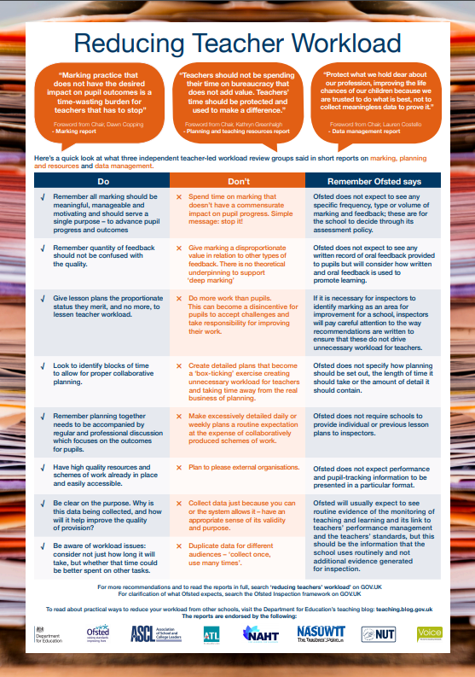

**Managing Your Workload**

Schools are working towards reducing any unnecessary burdens to teachers which add to workload. They are frequently sent guidance and updates from the Department for Education and you can read the most up-to-date information here: [www.gov.uk/guidance/reducing-workload-in-your-school](http://www.gov.uk/guidance/reducing-workload-in-your-school) Schools have also been sent clear guidance about how to manage the workload of teachers early in their careers. This is a useful document and you can read it so that you can understand the strategies that schools might be using to help you manage your workload: [www.gov.uk/government/publications/supporting-early-career-teachers-reducing-teacher-workload](http://www.gov.uk/government/publications/supporting-early-career-teachers-reducing-teacher-workload)

The ‘Reducing Teacher Workload’ poster is a useful summary of some approaches to thinking about how to manage the three key factors associated with workload – planning, marking and data. It is worth printing and keeping somewhere as a guide for how to keep focussed on the tasks that matter for your children’s progress and your development as a teacher. It will help you take responsibility also for managing the demands of the profession.

<https://www.gov.uk/government/publications/teacher-workload-poster-and-pamphlet>If you are concerned about your workload, talk to your **NQT mentor** who will provide you with guidance and support. Experienced colleagues often have excellent tips for managing workload. It is helpful to have a discussion with your mentor about the possible pressure points in the year – times when schools are especially busy or when there may be additional demands on your time, such as parent/carer consultation evenings – as the more you can plan for these in advance, the better. The **education unions** are a useful source of support for any concerns you have about wellbeing and workload, as well as all other professional matters. The two main unions are: The National Education Union - <https://neu.org.uk/> NASWUT - <https://www.nasuwt.org.uk/>It is highly recommended that you join a union and there is often a discount for NQTs. You may choose to join more than one and then select which provided you with the most helpful advice at the end of your NQT year.

We also recommend that you join the relevant Subject association for your curriculum specialism.



**PGCE**

**Secondary Education**   
**2019-2020**

**Congratulations!**

This is an informal indication of the completion of the Programme. Your QTS recommendation is passed to the DfE after you graduate by [registry@roehampton.ac.uk](mailto:registry@roehampton.ac.uk). This is usually in time for you to start in September. Please make a careful note of your Teacher Reference Number and register here: <https://teacherservices.education.gov.uk/SelfService/Login>

*Please ensure the following documents are on Abyasa and Moodle for consideration by your tutor. Take a screenshot as you complete the exit survey.*

|  |  |
| --- | --- |
| **Evidence document** | **Tutor signature** |
| Student Teacher’s Development Profile on Abyasa | Profile complete |
| Exit survey completed via Moodle (screenshot) | Exit survey complete |
| Evidence portfolio completed and peer assessed, Moodle | Portfolio complete |
|  |  |

*Signed by:*

Student teacher:

Subject tutor:

Date

**Keep in touch!**

**Need NQT support in a hurry?**

**Email** [**A.Messer@roehampton.ac.uk**](mailto:A.Messer@roehampton.ac.uk)

You will have access to your Roehampton email and other systems for 6 months after graduation. You will also have a year’s access to External Moodle including your portfolios, and we are planning for extended Library access. Further details will follow from the [Alumni](http://www.roehampton.ac.uk/Alumni/) office.

Please join our alumni group on Facebook: <https://www.facebook.com/groups/RoehamptonPGCESecondary14/>

If you are interested in continuing your study to MA (with alumni discounts) then see

[https://www.roehampton.ac.uk/postgraduate-courses/](https://eur02.safelinks.protection.outlook.com/?url=https%3A%2F%2Fwww.roehampton.ac.uk%2Fpostgraduate-courses%2F&data=02|01|A.Messer@roehampton.ac.uk|85e4b2fe91444ee58a5e08d6d30a0027|5fe650635c3747fbb4cce42659e607ed|0|0|636928437235395200&sdata=grG4LGMBNIIfGVzyhP5OGNL%2FfBSk0HV9dt86WjKWy3A%3D&reserved=0)

Tutors are here to support you into your NQT year.

There will be a virtual drop in each month.

Y*ou will receive termly emails to invite you to CPD events, including Wednesday 27th Jan (Research into Practice Conference) and 3rd March (Subject CPD for School Colleagues and NQTs – Twilight)*

|  |  |
| --- | --- |
| **English** | [Mari.Cruice@roehampton.ac.uk](mailto:Mari.Cruice@roehampton.ac.uk) |
| **Maths** | [N.Langford@roehampton.ac.uk](mailto:N.Langford@roehampton.ac.uk) |
| **Science** | [Steve.Abrams@roehampton.ac.uk](mailto:Steve.Abrams@roehampton.ac.uk) |
| **PE** | [Anita.Fiddes-Kapadia@roehampton.ac.uk](mailto:Anita.Fiddes-Kapadia@roehampton.ac.uk) |
| **History** | [A.Messer@roehampton.ac.uk](mailto:A.Messer@roehampton.ac.uk) |
| **Geography** | [Rachael.Butcher@roehampton.ac.uk](mailto:Rachael.Butcher@roehampton.ac.uk) |
| **D&T** | [P.Middleton-Heatley@roehampton.ac.uk](mailto:P.Middleton-Heatley@roehampton.ac.uk) |
| **Music** | [Kate.Potts-Lovegrove@roehampton.ac.uk](mailto:Kate.Potts-Lovegrove@roehampton.ac.uk) |
| **Art** | [R.Watts@roehampton.ac.uk](mailto:R.Watts@roehampton.ac.uk) |
| **Computing** | [m.berry@roehampton.ac.uk](mailto:m.berry@roehampton.ac.uk) |
| **Drama** | [Rebecca.Thompson@roehampton.ac.uk](mailto:Rebecca.Thompson@roehampton.ac.uk) |
| **RE** | [Lesley.Prior@roehampton.ac.uk](mailto:Lesley.Prior@roehampton.ac.uk) |
| **MFL** | [Nicholas.Power@roehampton.ac.uk](mailto:Nicholas.Power@roehampton.ac.uk) |
| *Consider following some university staff on twitter:* @freereed (Ali Messer) @maricruice @mberry | |

